**NAME :** DEVIKA K

**DEPARTMENT :**  INDUSTRIAL BIOTECHNOLOGY

**COLLEGE :** GOVERNMENTCOLLEGE OF TECHNOLOGY

**NAAN MUDHALVAN COURSE :** DIGITAL MARKETING

**NAAN MUDHALVAN ID :** 85A53F6B6BAA3AEAFBA4494E65651FC9

**ASSIGNMENT ON DIGITAL MARKETING**

1. Create a blog or website using blogspot and wordpress. Coustomize the theme design and post new article with 500 words

Wordpress:

<https://mywindin.wordpress.com/2023/10/30/cricket-worldcup/>

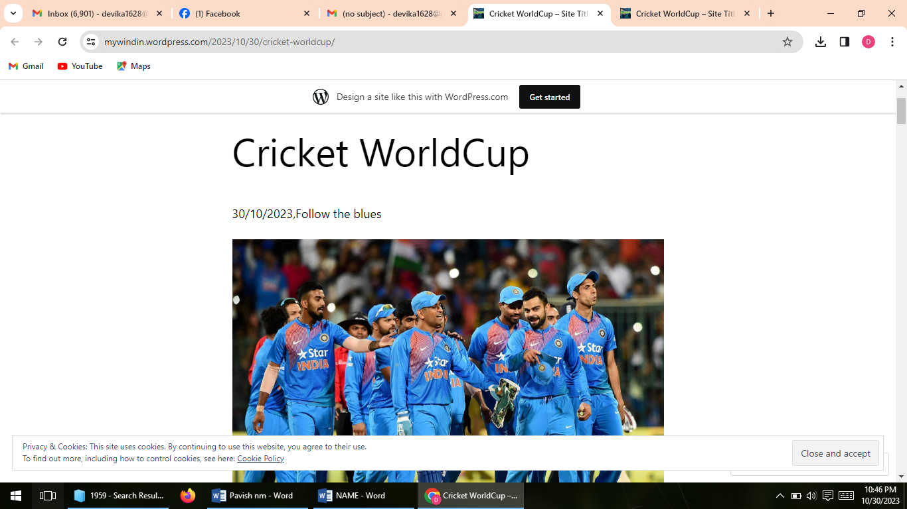

1. Create a new Facebook business page and post one social media poster for your brand

Facebook page link <https://business.facebook.com/latest?asset_id=163820370142654&nav_ref=mfb_get_started_header_cta>

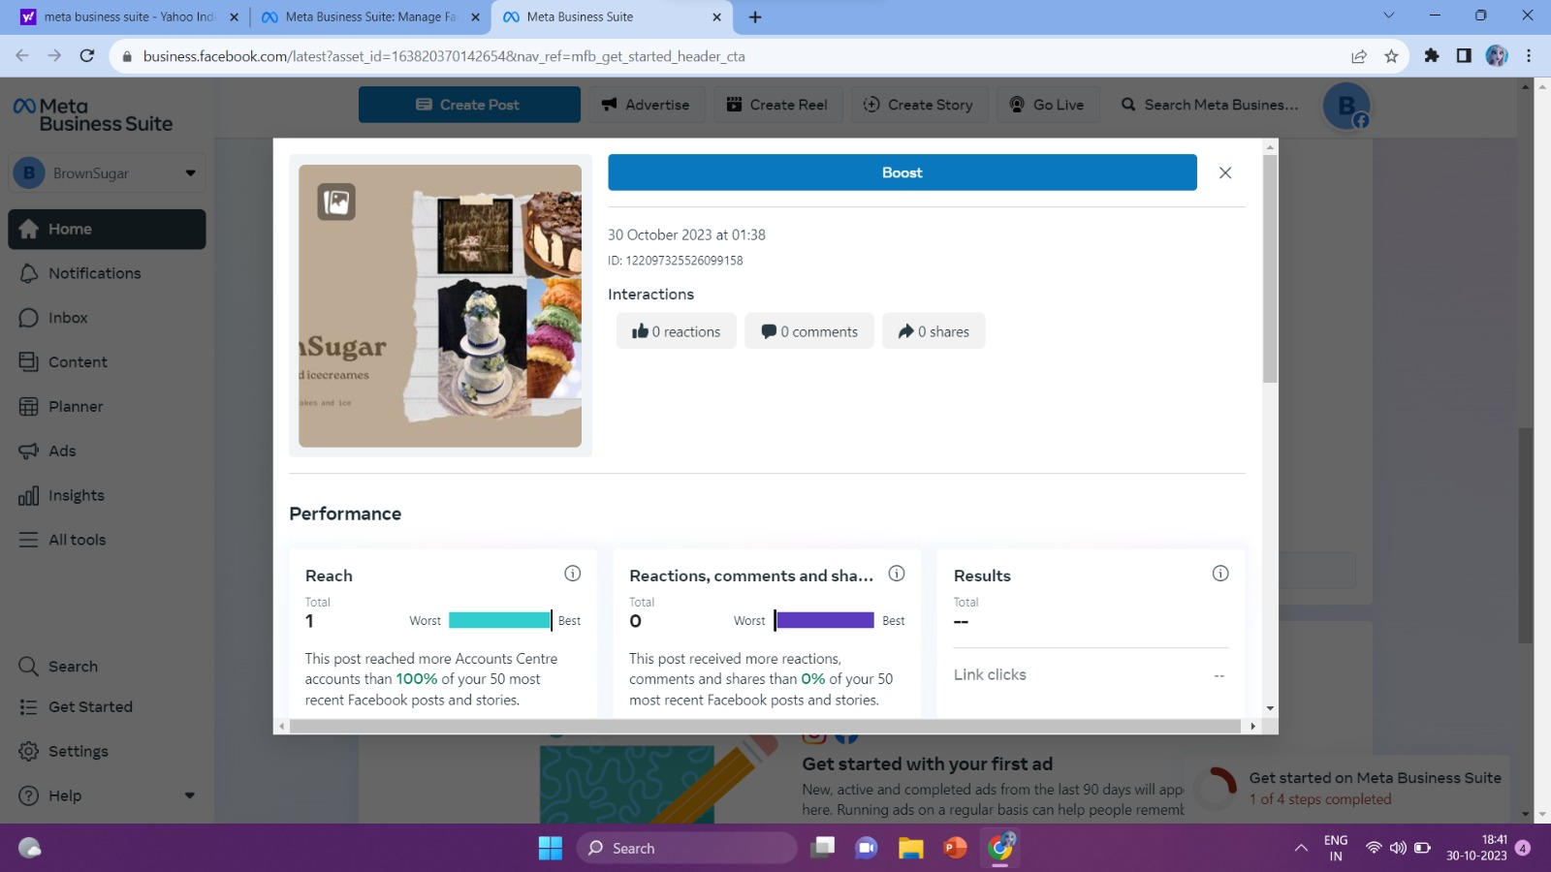

1. Create and design a social media advertisement poster using canva

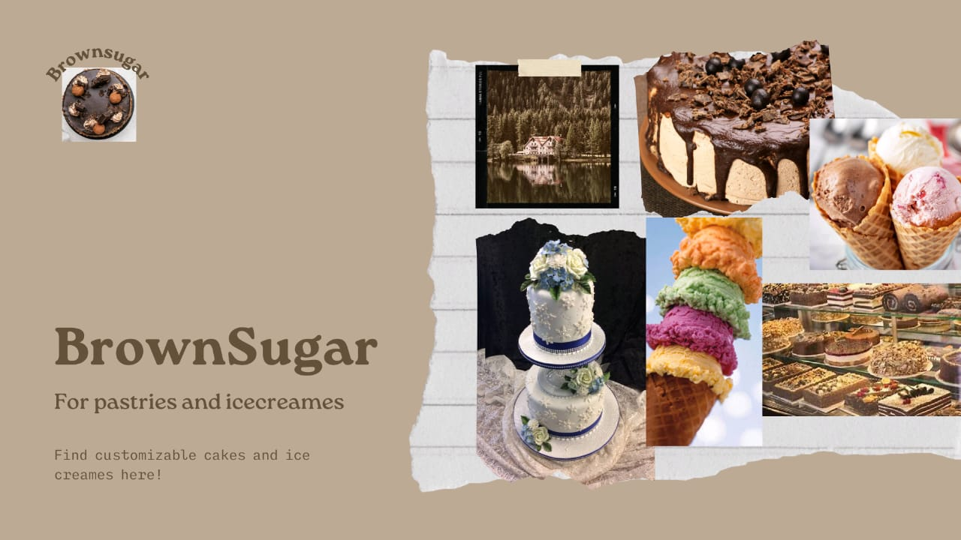

1. Create Email newsletter design using Mailchimp or canva tool

